Deployment groups:

Deployment groups is basically a connection between azure devops and the VMs.

We can find this under pipelines option.

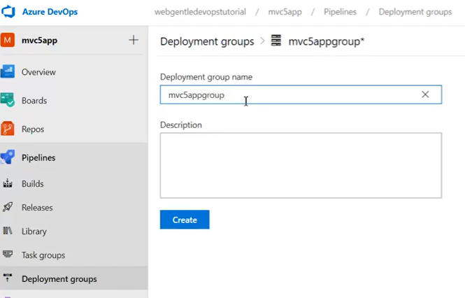

We can create a group by adding a name and description as above.

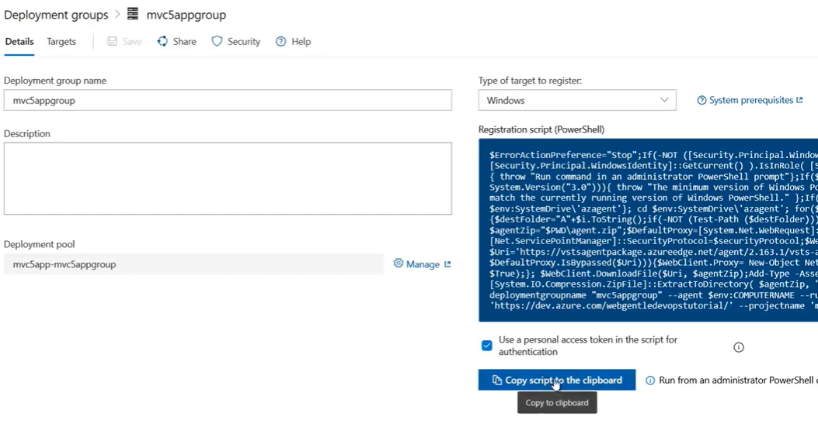

Once we click on create, we can select the type of server and it generates registration script which we need to run on the server to make the connection.

once this is done, we can see the group as below.

